8:15 Sunday School

Adults all ages Rm 309
Teachers: Jerry Clinard, Vic Owen

Special Needs Adults Rm 311
Teacher: Jill Hunt

9:30 Sunday School

Preschoolers
Preschoolers are age graded keeping in mind class size and motor skills of the child. Preschool classes are available all three worship hours. (9:30, 10:50, 12:00)

Babies A Rm 101
Babies B Rm 103

Walkers A Rm 105
Walkers B Rm 107

Twos A Rm 104
Twos B Rm 120

Threes A Rm 102
Threes B Rm 122
Fours Rm 119

All Children’s classes meet at 10:50

Adults
45 – 65 Single Again Ladies Rm 201
Teachers: Rovilla Sellars, Joy Milliren - These are single and single again ladies.

45 – 60 Adults Rm 307
Teachers: This class is coed, married couples and those attending singly.

50 – 70 Adults Rm 305
Teachers: Doris Nixon, Ray Jordan - This class includes married couples, widows and those attending singly. Most have grown children.

45 – 65 Adults Rm 303
Teachers: Steve & Francis Haynes - This class includes singles and married couples.

65 & Up Senior Adults Rm 207
Teachers: Karl Milliren, Nelson Bailey - Married Couples, widows and widowers.

55 & Up Victory Class Rm 203
Teacher: Beverly Owen - This class is all single ladies, married and widowed.

Special Needs Adults Rm 311
Teacher: Kevin & Robin Rogers

10:50 Sunday School

Preschoolers (same as 9:30)

Children
Kindergarten Rm 116 – 118

First Grade Rm 112

Second Grade Rm 111

Third Grade Rm 106

Fourth Grade Trailer

Fifth Grade Trailer

Sixth Grade The Loft

Special Needs Children Rm 121-123

Youth
Lower Level of the Office area

Seventh Grade
Teachers: Brittany Bryant,
Ryan & Amanda Remole, Kim & Rob Barkley

Eighth Grade
Teachers: Kristen & Casey Hane, Chris & Kelly James, Chad & Melissa Trogden

Ninth Grade
Teachers: Emily Bowers,
Nick & Amanda Land, Josh & Kristi Gailey

Tenth Grade
Teachers: Scottie & Dianne Carter,
David & Kristi Houser

Eleventh Grade
Teachers: Cathy Hudler, Paul Housand
Beth & Matt Rollins

Twelth Grade
Teachers: Mike & Pam Douglas,
Keith & Carmen Black

10:50 Sunday School continued

Adults
College and Career Rm 200
Teachers: Kim & Casey Hearn - This class is for those 18 and up. Most are college students and career individuals.

Singles 20 -30 Rm 407
Teachers: Marc Harris, Chad Smith

Singles 30’s & 40’s Rm 203
Teacher: Cathy & Mo Chilton - Single men and women.

Younger Married 20 – 35 Rm 315
Teachers: Phil Madison, Kevin Black - This class has many younger married and many have small children.

Married w/Children Rm 312
Teachers: Dana Myers, Steve Byerly - This class is made up of those 25 – 35 and most have children.

Adults 25 -40 Rm 305
Teacher: Mike Floyd - This class has couples and many have school aged children.

Adults 25 – 40 Rm 313
Teachers: Robbie Johnson, Glenn Rabon - This class has married adults with children some at home and some grown.

Adults 30 -49 Rm 303
Teachers: Robert Ware, Brent Byerly,

Coy Blair - This class is coed with children at home, college age or grown.

Adults 30 – 85 Rm 304
Teacher: Dave Rich - This class averages those in the 40 – 50 range but includes others, married and single. Some have children at home, college or grown.

Adults 30 – 50 Rm 307
Teacher: Jack Grissom - This class is coed,
some have children at home, college or grown.

Adults 35 – 50 Rm 309
Teachers: Randy Waters, Scott Garner -
This class is coed, most with children at home.

Adults 30 – 50 Rm 316
Teachers: Ed Tobin, Bonnie Murdock - This class is coed and many have grown children.

Adults 50 – 65 Rm 207
Teacher: Jeff Eddinger - This class is coed, most have grown children.

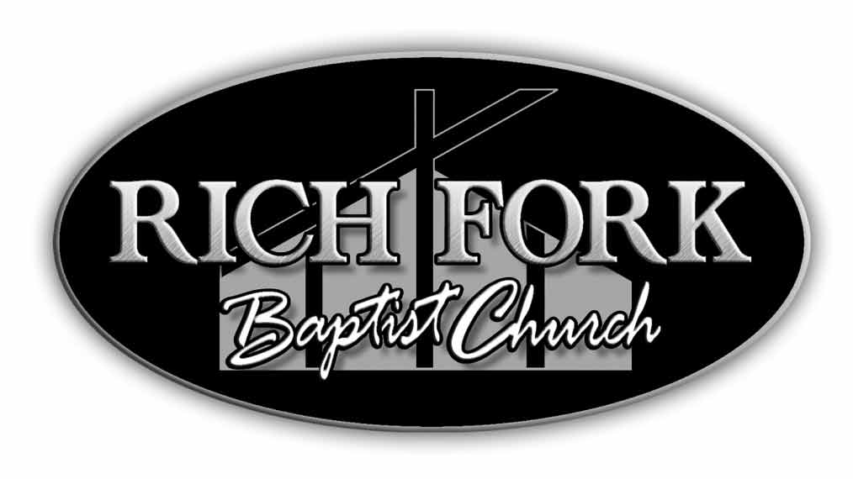

Rich Fork Sunday School

May 2012

